The Dogue de Bordeaux Society of America is a 501©3 nonprofit organization which was formed by a team of individuals who wanted to provide a common area for the Dogue de Bordeaux and its enthusiasts to come together as one for the love of the breed. The DDBS was officially a recognized organization in February of 1997.  In 2004, the DDBS was appointed as the club that the AKC FSS recommended for AKC Parent Club Status for the Dogue de Bordeaux. In 2006, the Dogue de Bordeaux was officially moved to the AKC Miscellaneous Class and July 1, 2008, the breed officially moved to the AKC Working Group. In 2006, the DDBS officially changed its name to the Dogue de Bordeaux Society of America – the DDBSA.  Website: www.ddbsa.org  Email: info@ddbsa.org  Rescue Email: ddbsarescue@yahoo.com  PayPal donations can be made to this address  Visit us on Facebook! |  |  | DDBSA National Specialty Sponsors  We would like to thank the following people for their support!  Platinum  Ivan Peric  Gold  Ivan Peric  Silver  Deana Crutcher  General  Scott & Angie Reed  Mike & Kathi Cannon  Donors  Angie and Scott Reed  Val and Rick Barr  Mike and Kathi Cannon  Corporate Sponsors  Acana  Big Dog Brewing Company  Buckle Down Collars  Bulldogge Nation Miracle Balm  Champion Pet Food  Coats Made by De  Gold Paw Series  Group Management Services  Jeffers Pets  Lupine  Mastiff Dog Online Store  Natural Balance  Natural Dog Company  Nelson’s (makers of Rescue Remedy)  Nordic Naturals  Pet King Brands  Picaboo  Rising Star Crates  The Blissful Dog  Treadwell  TruDog  VIP Products

DDBSA Rescue  DDBSA Rescue needs your help!! Volunteers are always needed to do home checks, evaluate and pull dogues, transport and foster. Anything you have time to do is greatly appreciated! Currently Viola Shannon is looking for like-minded folks to join the DDBSA Rescue Committee to organize, evaluate paperwork, fund raise and structure our program since we are a National rescue. Viola and her volunteers will be at the Rescue table, so stop by and see what you can do to help.  Viola has tutus for sale and has a silent auction going on in the Club tent. Be sure to check it out! (If you forgot about the costume contest, buy a tutu!)  This girl to the left his Hazel, one of the rescues that we were able to help after her owner died of cancer. She is currently in a foster to adopt home where she is getting all the love and attention that she can handle.  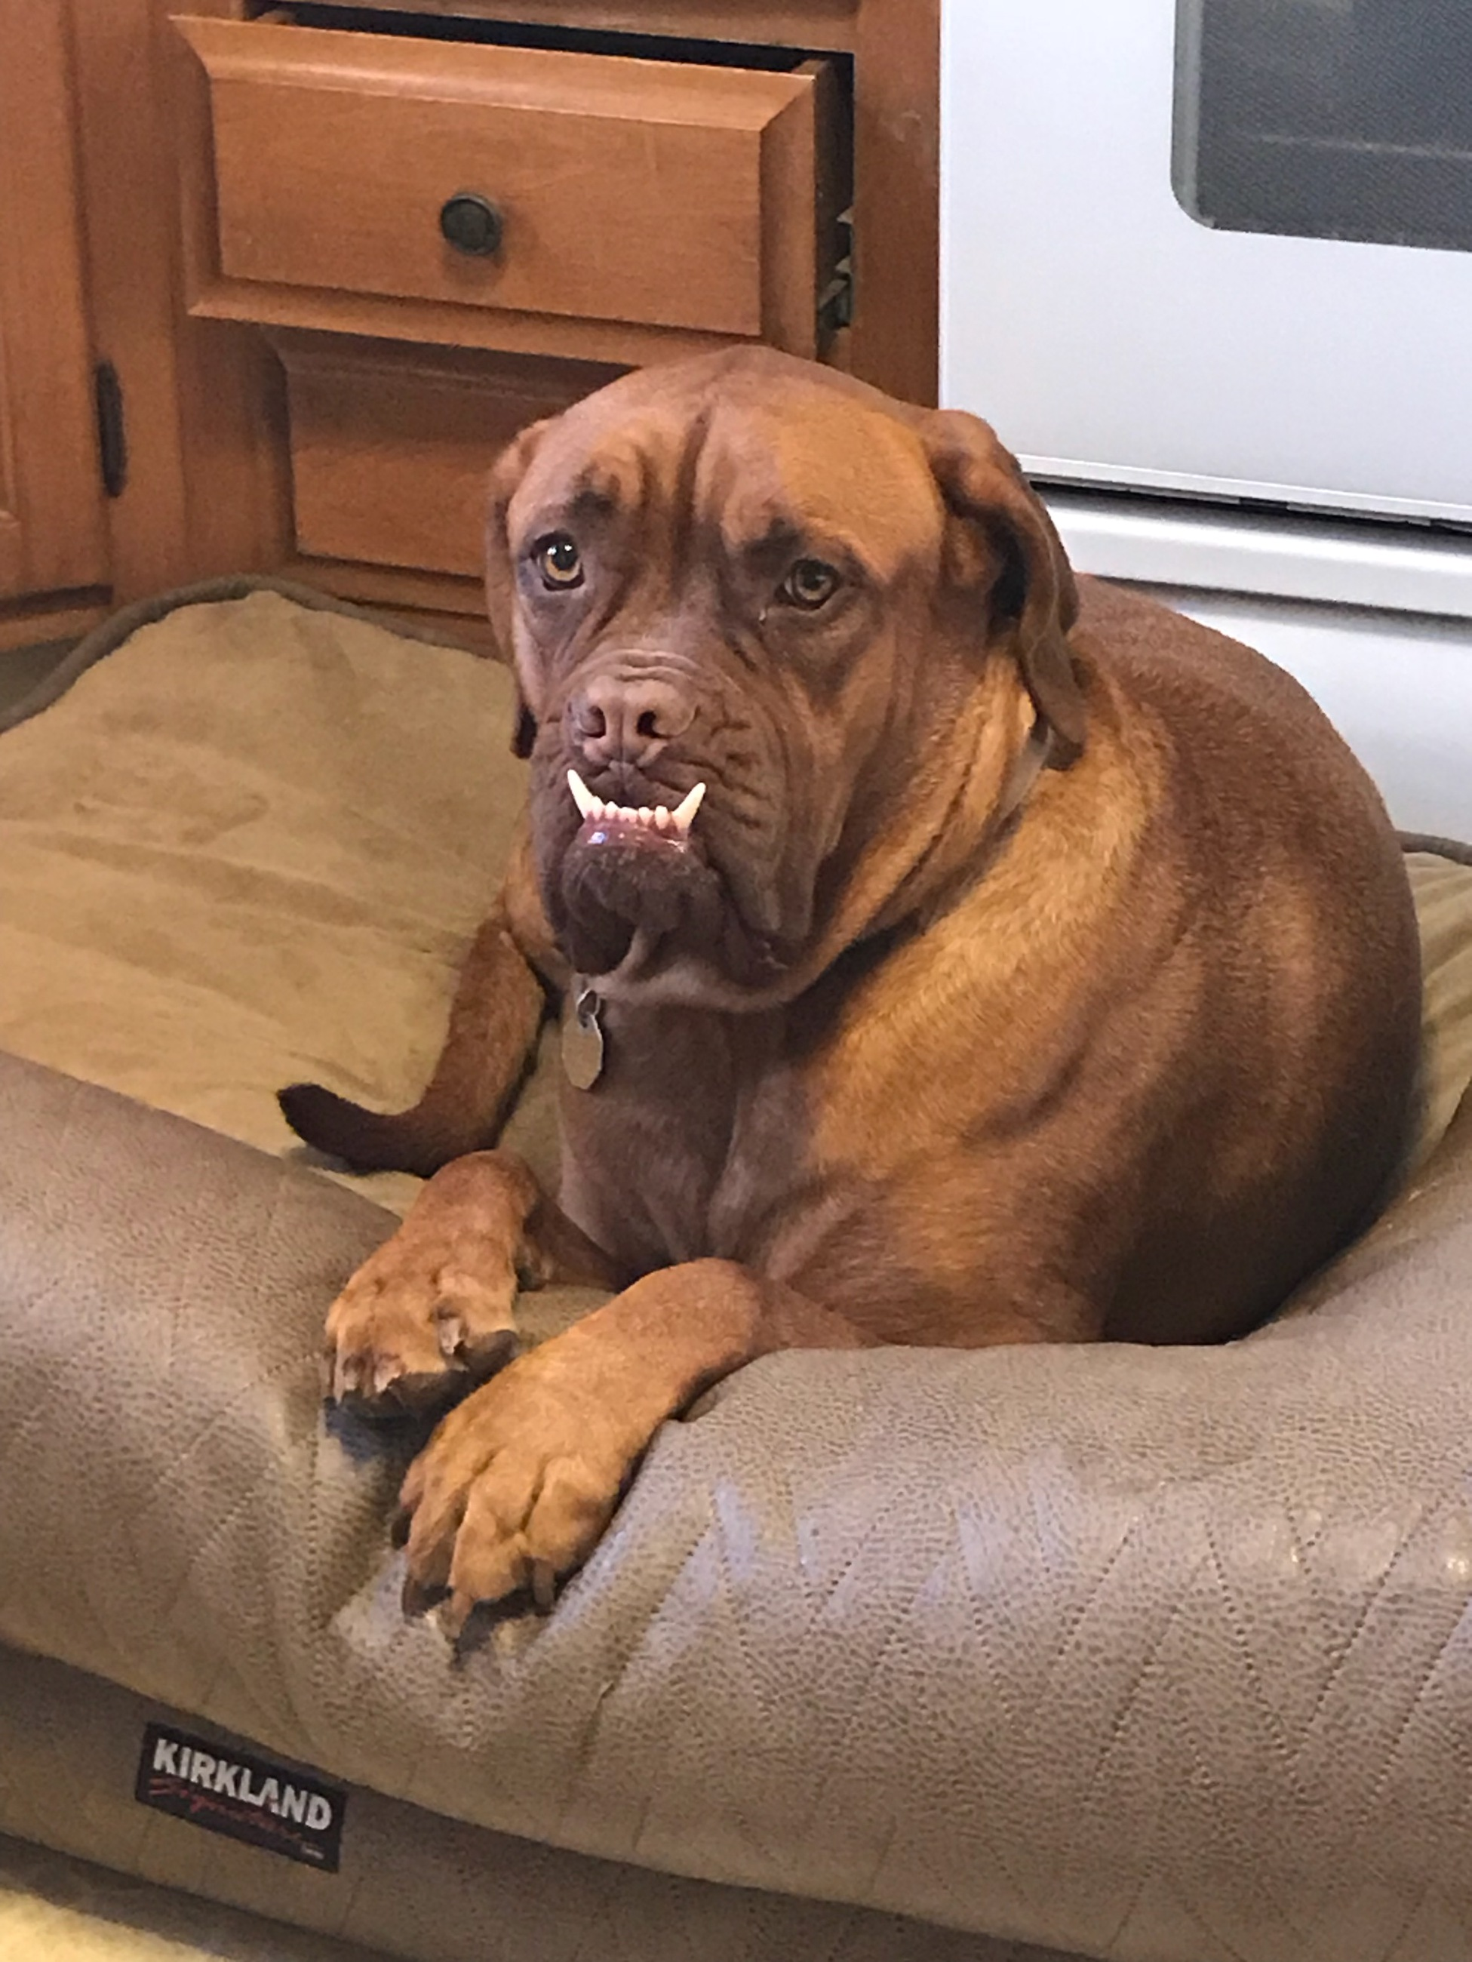  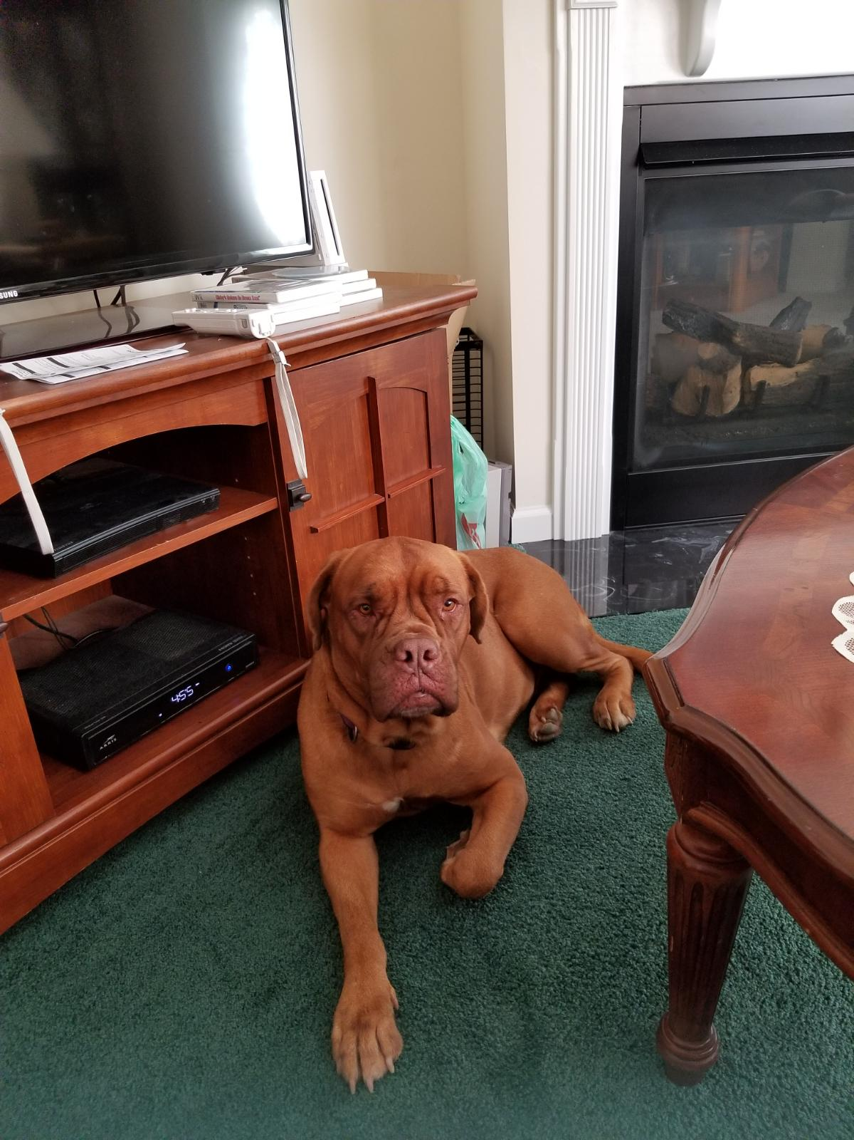  This little girl to the right is Daphne, who was with a family who no longer could care for her. DDBSA members worked together to get her from southern Ohio to Pennsylvania for foster and she has been adopted to a wonderful family in New York with other rescues in the family that love her dearly! |  |  | AKC Code of Sportsmanship (con’t.)  - The sportsman respects the AKC bylaws, rules, regulations and policies governing the sport of purebred dogs.  - Sportsmen find that vigorous competition and civility are not inconsistent and are able to appreciate the merit of their competition and the effort of competitors.  - Sportsmen welcome, encourage and support newcomers to the sport.  - Sportsmen will deal fairly with all those who trade with them.  - Sportsmen are willing to share honest and open appraisals of both the strengths and weaknesses of their breeding stock.  - Sportsmen spurn any opportunity to take personal advantage of positions offered or bestowed upon them.  - Sportsmen always consider as paramount the welfare of their dog.  Sportsmen refuse to embarrass the sport, the American Kennel Club or themselves while taking part in the sport.
 |  |  | 5

AKC Code of Sportsmanship  PREFACE: The sport of purebred dog competitive events dates prior to 1884, the year of AKC’s birth. Shared values of those involved in the sport include principles of sportsmanship. They are practiced in all sectors of our sport: conformation, performance and companion. Many believe that these principles of sportsmanship are the prime reason why our sport has thrived for over one hundred years. With the belief that it is useful to periodically articulate the fundamentals of our sport, this code is presented.  - Sportsmen respect the history, traditions and integrity of the sport of purebred dogs.  - Sportsmen commit themselves to the value of fair play, honesty, courtesy and vigorous competition, as well as winning and losing with grace.  - Sportsmen refuse to compromise their commitment and obligation to the sport of purebred dogs by injecting personal advantage or consideration into their decisions or behavior.  - The sportsman judge judges only on the merits of the dogs and considers no other factors.  - The sportsman judge or exhibitor accepts constructive criticism.  - The sportsman exhibitor declines to enter or exhibit under a judge where it might reasonably appear that the judge’s placements could be based on something other than the merits of the dogs.  - The sportsman exhibitor refuses to compromise the impartiality of a judge. |  |  | 2018 Supported Entry Trophy List  Friday 9/21/2018 Supported Entry – Sponsored by Prodigy Bordeaux  BOB – Metal Menagerie Welcome Sign  BOS – Metal Menagerie Card Holder  WD – Metal Menagerie Leash Holder  WB – Metal Menagerie Leash Holder  Owner Handled – Metal Menagerie Zipper Pull  Saturday 9/22/2018 – Specialty Day!  Sunday 9/23/2018 Supported Entry – Sponsored by Vigoreaux Bordeaux  BOB – Cactus Theme Serving Tray  BOS – Cactus Ceramic Treat Jar  WD – Cactus Ceramic Treat Jar  WB – Cactus Ceramic Treat Jar  Owner Handled – Cactus Ceramic Treat Jar  Monday 9/24/2018 Supported Entry – Sponsored by Rising Star Bordeaux  BOB - $25 Cash & Toy  BOS - $20 Cash & Toy  WD - $15 Cash & Toy  WB - $15 Cash & Toy  Owner Handled - $10 Cash & Toy
4 |  |  | 1

Saturday 9/22/2018 – National Specialty  Trophy Item Description Sponsored By  BOB Embroidered Chair, Prodigy Bordeaux  Cooler Tote, Art Print  BOS Embroidered Chair, Gale Bandsma, Buckaroo  Drool Towel Bordeaux  Select Dog Custom Engraved Tim & Sonja Tompkins  Flash Drive & Tote  Bag  Select Bitch Custom Engraved Tim & Sonja Tompkins  Flash Drive & Tote  Bag  Award of Merit 1 Gift Bag Rua Ri Bordeaux  Award of Merit 2 Gift Bag  Award of Merit 3 Gift Bag  Best of Winners Engraved Wine Glass Anthony DiNobile  Set & Slavi Artwork  Winners Dog Cooler Tote Ru Ari Bordeaux  Winners Bitch Cooler Tote Ru Ari Bordeaux |  |  | Hindquarters, good extension of the forelegs, especially at the trot which is the preferred gait. As the trot quickens the head tends to drop, the topline inclines towards the front and the front feet get closer to the median plane while striding out with a long reaching movement. Vertical movement while in a short gallop is rather important. He is capable of great speed over short distances by bolting along close to the ground. Temperament – Dogue de Bordeaux is gifted for guarding which he assumes with vigilance and great courage but without aggressiveness. He is a very good companion, being attached to and affectionate toward his master. He is calm and balanced with a high stimulus threshold. The male normally has a dominant character.  The foregoing is a description of the ideal Dogue de Bordeaux. Any deviation should be penalized in direct proportion to the extent of that deviation. Extreme deviation in any part should be penalized to the extent that the dog is effectively eliminated from competition.  Disqualifications: Mouth not undershot; wry jaw. An atrophied tail or tail that is knotted and laterally deviated or twisted. White on the head or body, limited white patches permissible on the chest and the extremities of the limbs, or any coat color other than shades of fawn.  APPROVED OCTOBER 9, 2007  EFFECTIVE DATE JULY 1, 2008
2 |  |  | 3

