Powerful, prominent muscles. Slant of shoulder – blade is medium (about 45 degrees to the horizontal), with the angle of the scapular-humeral articulation being a little more than 90 degrees. Arms – Very muscular. Elbows – in line with the body. Should be neither too close to the chest nor turned out. Forearms – When viewed from the front, straight or inclining inwards, especially in dogs with a very broad chest. When viewed in profile, vertical. Pasterns – Powerful. Slightly sloping when viewed in profile. When viewed from the front may bend slightly outwards, thus compensating for the slight inclination of the forearm inwards. Feet – Strong. Toes should be tight, nails curved and strong and pads well developed and supple; the Dogue is well up on his toes despite his weight.  Hindquarters - Powerful legs with strong bone structure, well angulated. When viewed from behind, the hindquarters are parallel and vertical thus giving an impression of power. The hindquarters are not quite as broad as the forequarters. Thigh – Well developed and thick with visible muscles. Stiifle – in a parallel plane to the median plane or slightly out. Second Thigh – Relatively short, well-muscled. Hock Joint – Short and sinewy, with the angle of the hock joint moderately open. Hock – Strong, no dewclaws. Hind Feet – Slightly longer than the front feet, toes should be tight.  Coat – Fine, short and soft to the touch. Skin – Thick and sufficiently loose fitting. Color: Coat – self-colored, in all shades of fawn, from a dark red fawn to a light fawn. A rich coat color is considered desirable. Limited white patches are permissible on the chest and extremities of the limbs. Fault: White on the tip of the tail, or on the front part of the forelegs above the carpus and the tarsus. Disqualification: White on the head or body, or any coat color other than shades of fawn. Black Mask – The mask is often only slightly spread out and should not invade the cranial region. There may be slight black shading on the skull, ears, neck and back. Pigmentation of the nose will be black. Brown Mask – Pigmentation of the nose and eye rims will also be brown. No Mask – The coat is fawn, the skin appears red (also formerly called “red mask”) and the nose is then reddish or pink.  Gait – The gait is quite supple for a mollossoid. In open walking the movement is free, supple, close to the ground. Good drive from the |  |  | Saturday 9/22/2018 – National Specialty  Trophy Item Description Sponsored By  Reserve WD Custom Engraved Scott & Angie Reed  Flash Drive  Reserve WB Custom Engraved Scott & Angie Reed  Flash Drive  Best Bred By Custom Engraved Woodland Park Bordeaux  Flash Drive  Best Veteran Custom Engraved Scott & Angie Reed  Flash Drive  Best Puppy DDB Leash Holder Scott & Angie Reed  Stud Dog Gift Bag Scott & Angie Reed  Brood Bitch Gift Bag Proudly Sponsored by GCH  Heartstrings Margaret CGC,  2017 Best Brood Bitch,  2017 Best Veteran, 2016  DDBSA Dam of the Year  Owner Handled Custom Engraved Scott & Angie Reed  Flash Drive  Rally – High Comb Gift Bag Anonymous in memory of  Snapper Creek’s Love Her  Madly - Maqui  Parade of Rescues Gift Bag The Blissful Dog

Sunday Sweepstakes  Sponsored by – George & Maryanna Herrington, in Memory of Pelli,  Tesssa, Winnie & Digger the old rescue dog. We love you and miss you.  Puppy Sweepstakes – % of Money, Pet Mat & Toy  Veteran Sweepstakes – % of Money, Storage Bin & Decal  Owner Handled Sweepstakes – % of Money, Storage Bin & Decal  Bred By Sweepstakes - % of Money, Storage Bin & Decal  Best In Sweepstakes – % of Money, Wine Glass Set  Each Dogue de Bordeaux entered in either sweepstakes must be handled by owner, by a member of the owner’s immediate family or by an amateur handler with the exception that professional handlers may handle only dogues that they own or are the breeder/co-breeder of record and handle with recompense, all prize money is the property of the owner.  Any wins in Sweepstakes or Veteran Sweepstakes do not qualify the winner to compete for Best of Breed competition.  Veteran Sweeps: Open to all Dogue de Bordeaux that are six years of age or over on the day of the show. Dogs need not be entered in a regular class to enter or at the regular entry fee. Spayed and neutered dogs are eligible to enter. The following classes will be provided for both dogs and bitches: Veteran 6-8 years, Veteran 8-10 years, Veteran 10 and over. The winners from each class will compete for Best Veteran in Sweeps and Best Opposite in Sweeps. The Club will retain 35% of the entry fees for expenses. The remaining 65% will be divided in each class as the following: first 35%, second 15%, third 10%, fourth 5%.  Best in Sweeps: Open to all Dogue de Bordeaux that are at least six months of age and under 18 months on the day of the show. All Dogue de Bordeaux entered in the Sweepstakes class must be entered in a regular class for Best of Breed competition at this show and at the regular entry fee on the official form. Sweepstakes classification for both dogs and bitches: 6-9 months, 9-12 months, 12-15 months, 15-18 months. Winners of each group will compete for Best in Sweeps and Best of Opposite in Sweeps. The Club will retain 35% of the entry fees for expenses. The remaining 65% will be divided in each class as the following: first 35%, second 15%, third 10%, fourth 5%. |  |  | The lower jaw curves upwards. The chin is very pronounced and should neither overlap the upper lip exaggeratedly nor be covered by it. Disqualification – Mouth not undershot; wry jaw.  Bite – Undershot. Fault – Incisors constantly visible when the mouth is closed. Severe Fault – Canines constantly visible when the mouth is closed. Teeth – Strong, particularly the canines. Lower canines set wide apart and slightly curved. Incisors well aligned especially in the lower jaw where they form a straight line. Severe Fault – Long narrow head with insufficiently pronounced stop, with a muzzle measuring more than a third of the total length of the head (lack of type in head).  Neck, Topline and Body – Neck – Very strong and muscular, almost cylindrical. The skin is supple, ample and loose. The average circumference almost equals that of the head. There is a noticeable, slightly convex, furrow at the junction of the head and the neck. The well-defined dewlap starts at the level of the throat forming folds down to the chest, without hanging exaggeratedly. The neck is very broad at its base, merging smoothly with the shoulders. Topline – Solid with a broad and muscular back, withers well marked, broad loin, rather short and solid. Chest – Powerful, long, deep, broad and let down lower than the elbows. The forechest is broad and powerful with a lower line that is convex towards the bottom. The ribcage is deep and well sprung, but not barrel shaped. The circumference of the chest should be between 10 and 12 inches greater than the height at the withers. Underline – Curved, from the deep brisket to the firm abdomen. Slight to moderate tuck-up. Should be neither pendulous nor extreme. Croup – Moderately sloping down to the root of the tail. Tail – Very thick at the base. The tip preferably reaches the hock but not below. Carried low, it is neither broken nor kinked but supple. Hanging when the dog is in repose; generally carried level with the back or slightly above the level of the back when the dog is in action, without curving over the back or being curled. Fault – Fused vertebrae but not kinked. Disqualification – An atrophied tail or a tail that is knotted and laterally deviated or twisted.  Forequarters – Strong bone structure, legs very muscular. Shoulders -

2017 Annual Working Dog Awards  Each year the Working Dog Committee recognizes those Dogues who have received a working title with a commemorative medallion. In 2017, 6 Dogues received titles consisting of Obedience, Rally, CGC, and Temperament titles. The recipients of the 2017 WD Medallions are:  Blue Diamonds Just Like Fyre owned by Jennifer Peck, Rebecca Randolph and Kimberly Thomsen  Brickmoor’s Unsinkable Spirit owned by Linda Pacioretty and John Babish  Larua Los Picasos owned by Paula and Tom Fultz  Prodigy's A Drop of Irish Swagger owned by Jennifer Peck, Rebecca Randolph and Lauren Parker  Snapper Creek's Sista Big Bones owned by Paula and Tom Fultz  Snapper Creek’s Love Her Madly owned by Linda Pacioretty and John Babish  In addition to honoring those Dogues who have earned titles, the WD Committee recognizes the Dogue earning the most titles in 2017. This Dogue is Brickmoor’s Unsinkable Spirit owned by Linda Pacioretty and John Babish who earned 3 titles in 2017.  Finally, the WD Committee recognizes the overall #1 working Dogue de Bordeaux – the Dogue that has earned the most titles in its career. This Dogue is also inducted into the Working Dog Hall of Fame. The 2017 #1 Working Dog is awarded to Snapper Creek’s Love Her Madly, “Maqui”, owned by Linda Pacioretty and John Babish. Maqui has earned 38 titles consisting of obedience, rally, agility, tracking, and CGC.  The 2017 Annual Working Dog commemorative medallions were donated by the Working Dog Ability Committee.  . |  |  | American Kennel Club Official Standard of the Dogue de Bordeaux  General Appearance – The Dogue de Bordeaux is one of the most ancient French breeds. He is a typical brachycephalic molossoid type. He is a very powerful dog, with a very muscular body yet retaining a harmonious general outline. Built rather close to the ground, the distance from the deepest point of the chest to the ground is slightly less than the depth of the chest. A massive head with proper proportions and features is an important characteristic of the breed. His serious expression, stocky and athletic build, and self-assurance make him very imposing. Bitches have identical characteristics, but less prominent.  Size, Proportion, Substance – The length of the body, measured from the point of the shoulder to the point of the buttock, is greater than the height at the withers, in the proportion of 11/10. The depth of the chest is more than half the height at the withers.  Size – Dogs: 23 ½ to 27 inches at the withers. Bitches: 23 to 26 inches at the withers. Weight – Dogs at least 110 pounds, Bitches at least 99 pounds.  Head – The head is large, angular, broad and rather short. It is trapezium shaped when viewed from above and in front.  Eyes – Oval and set wide apart. The space between the eyes is equal to about twice the length of the eye (eye opening). Frank expression. The haw should not be visible. Color – hazel to dark brown for a dog with a black mask, lighter color tolerated but not sought after in dogs with either a brown mask or without a mask. Fault – protruding eyes.  Ears – The ear is small in proportion to the skull and of a slightly darker color than the coat. The front of the ears’ base is slightly raised. They should fall back, but not hang limply. The front edge of the ear is close to the cheek when the dog is attentive. The tip is slightly rounded and should not reach beyond the eye. Set rather high, at the level of the upper line of the skull, thus emphasizing the skull width even more.  Skull – Back Skull in the male: The perimeter of the skull measured at the point of its greatest width corresponds roughly to the height at the withers. In
4

Bitches it may be slightly less. Its volume and shape are the result of the spacing of the lower jaw bones and the very well-developed temporal area, upper-orbital area and zygomatic arches. The cheeks are prominent due to the very strong development of the muscles. The skull is slightly rounded from one side to the other. The frontal groove is deep. The forehead, characterized by well developed eyebrows, dominates the face. However, the skull is still wider than high. The head is furrowed with symmetrical wrinkles on each side of the median groove. These deep ropes of wrinkle are mobile depending on whether the dog is attentive or not. Stop – The stop is very pronounced, almost forming a right angle with the muzzle (95 to 100 degrees). Fault – Extreme characteristics such as a very short muzzle, flat skull and a swollen fold behind the nose.  Muzzle – Powerful, broad, thick and rather short. Should not be fleshy below the eyes. When viewed in profile, the foreface is very slightly concave with moderately obvious folds. Its width decreases only slightly from the root of the muzzle to the tip. When viewed from above it has the general shape of a square. When viewed from the side the top lines of the skull and muzzle form an angle that converges at, or near, the end of the muzzle. When the head is held horizontally the end of the muzzle, which is truncated, thick and broad at the base, is in front of a vertical tangent to the front of the nose. (The nose is slightly set back from the front of the muzzle.) Its perimeter is almost two thirds of that of the head. Its length varies between one third and one quarter of the total length of the head, measured from the nose to the occipital crest. The ideal length of the muzzle is between these two extremes.  Nose – Broad, with well opened nostrils. Self-colored according to the color of the mask. Slightly upturned permissible. Upper lip – Thick, moderately pendulous yet retractile. When viewed in profile it shows a rounded lower line and covers the lower jaw on the sides. When viewed from the front, the edge of the upper lip is in contact with the lower lip and droops on either side thus forming an inverse, wide V. Jaws – very powerful and broad. Undershot so that there is no contact between the upper and lower incisors. |  |  | 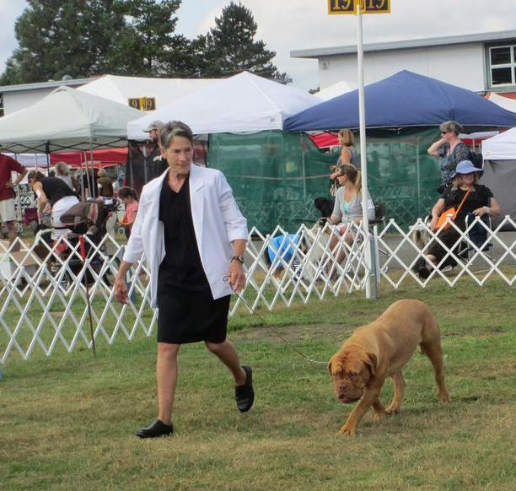  Those we meet along life’s journey help shape us and make us into the people we are today.  Congratulations to all our exhibitors!  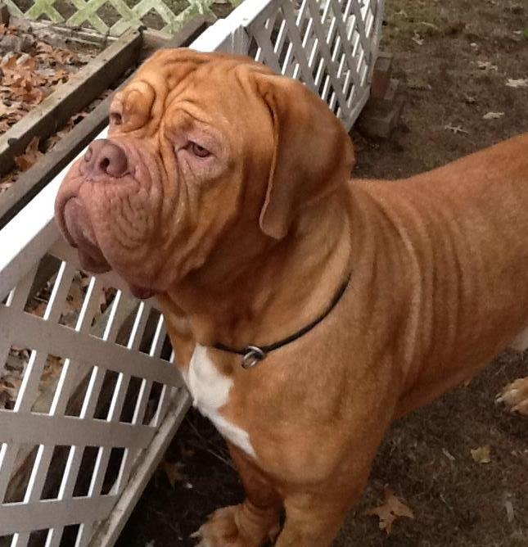  With us in spirit as we celebrate our 20th National Specialty Show, Dianne Morrison and Seraphs Scimitar at Cantoure. Forever loved, forever missed.
2 |  |  | Kathi and Mike Cannon | 3

