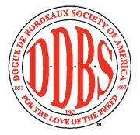

DDBSA VERSATILITY AWARD
AND VERSATILITY EXCELLENT AWARD APPLICATION
Dog’s Registered Name:__________________________________________________
AKC Registration Number:________________________________________________

Dog’s Titles:
Conformation: _________________________________________________________
Category A: Obedience __________________________________________________
Category B: Rally ______________________________________________________
Category C: Agility _____________________________________________________
Category D: Tracking____________________________________________________
Category E: Weight Pulling _______________________________________________
Category F: Carting _____________________________________________________
Category G: Schutzhund ________________________________________________
Category H: Miscellaneous _______________________________________________

Owner(s):_____________________________________________________________

Address:______________________________________________________________

_____________________________________________________________________

Phone:____________________________ E-mail:_____________________________

Mail application along with photocopies of all titles, certificates (including CH certificate), etc. to:
Linda Pacioretty
DDBSA Versatility Program
508 White Church Rd.
Brooktondale, NY 14817
or
lp@bionxs.com

